nodejs Fundamentals for Window

This document shows some basic information about nodejs.

# Installing nodejs

**General information**

Referring to <http://en.wikipedia.org/wiki/Node.js> : Node.js is a cross-platform runtime environment for server-side and networking applications. Node.js applications are written in JavaScript, and can be run within the Node.js runtime on Mac OS X, Windows and Linux with no changes.

Referring to <http://nodejs.org/> : Node.js® is a platform built on Chrome's JavaScript runtime for easily building fast, scalable network applications. Node.js uses an event-driven, non-blocking I/O model that makes it lightweight and efficient, perfect for data-intensive real-time applications that run across distributed devices.

At this point, we use ***nodejs v0.10.29*** to install. You can download it at: <http://nodejs.org/download/>.

Run node-v0.10.29-x86.msi file and choose directory to install as:

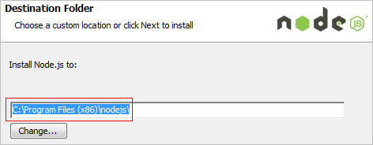

It will install nodejs and npm into your system. You can check it as:

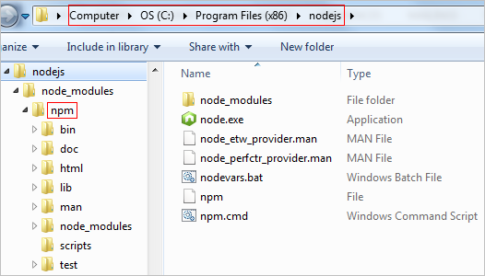

And you can use command line to check the version of nodejs as:

*>node -v*

Now, nodejs is ready for using.

# Configuring new site with nodejs

nodejs can manage Javascript site/application such as AngularJS.

Writing ….